 |  | DECLARATION OF  CONFORMITY  (IZJAVA O SUKLADNOSTI) |  |  | 
We, (Mi) | ENVOX d.o.o.  Zagreb, Croatia
declare under our sole responsibility that the product
(izjavljujemo pod punom odgovornošću da je proizvod)

Type, Model:  (Tip, Model): |  | EEZ BB3 STM32F7
Brand Name:  (Komercijalni naziv): |  | EEZ Bench Box 3
Product:  (Proizvod): |  | Modular test and measurement chassis  Modularna šasija za testne i mjerne module
Product Options:  (Varijante proizvoda): |  | This declaration covers all options of the above product(s) with DCP405 and DCM224 power modules  (Ova deklaracija uključuje sve varijante gore navedenog proizvoda s DCP450 i DCM224 perifernim modulima.)
is in conformity with the essential requirements of Directives and regulations
(sukladan bitnim zahtjevima Direktiva i propisa):
Electromagnetic compatibility Directive ( 2014/30/EU ), LVD Directive (2014/35/EU), ROHS Directive (2011/65/EU), Ecodesign Directive (2009/125/EC), Regulation (EC) 278/2009
Pravilnik o elektromagnetskoj kompatibilnosti (NN br.28/2016), Pravilnik o električnoj opremi namijenjenoj za uporabu unutar određenih naponskih granica (NN br.43/2016), Pravilnik o ograničavanju uporabe određenih opasnih tvari u električnoj i elektroničkoj opremi (NN br.131/2013, 16/2014, 90/2014, 142/14), Pravilnik o utvrđivanju zahtjeva za ekološki dizajn proizvoda povezanih s energijom (NN br. 80/2013), Uredba (EK) 278/2009
by applying the following standards (primjenom slijedećih normi):

- EN 61326-1:2013 (HRN EN 61326-1:2013) Emission limits-class A according to CISPR11, Immunity values according to table 2 except BURST test that comply with Criteria C
- EN IEC 61000-3-2:2019 (EN IEC 61000-3-2:2019)
- EN 61000-3-3:2013+A1:2019 (HRN EN 61000-3-3:2013)
- EN 61010-1:2010 (HRN EN 61010-1:2010)
- EN 62311:2008

Supplementary Information:
This product is intended for use in a basic electromagnetic environment.
This is a sensitive measurement apparatus by design and may have some performance loss when exposed to ambient continuous electromagnetic phenomenon.

The CE marking is affixed from the year (CE oznaka stavljena na proizvod): 2021
Zagreb, Croatia  23.03.2021. |  |  | 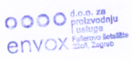 | 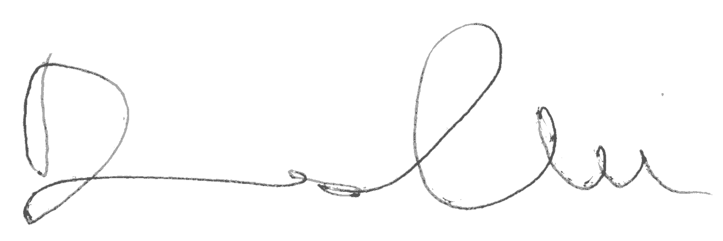  Denis Kotlar

Document name: CE Doc EEZ BB3 (2021-03)

